How to Launch a Jupyter Notebook on Windows

1. Open Windows Start Button and Select Anaconda3 Folder
2. 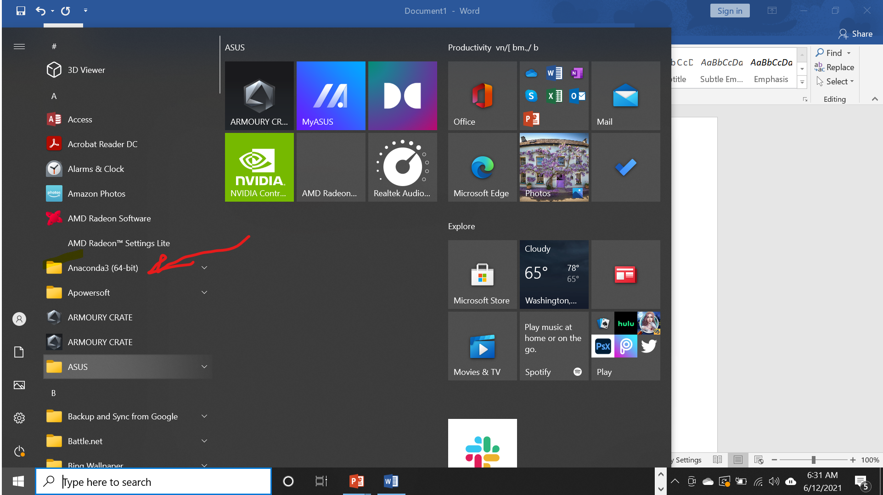
3. Next Click Anaconda PowerShell Prompt
4. 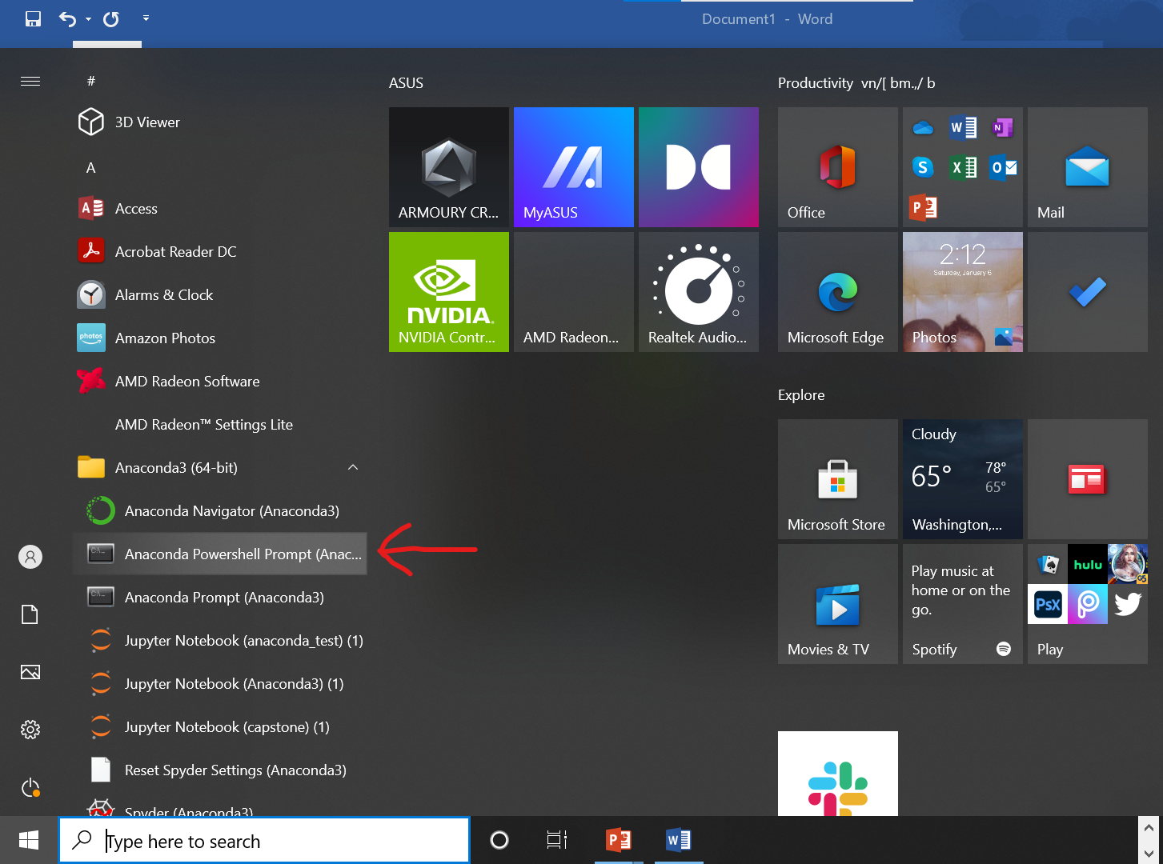
5. This will open the Anaconda PowerShell Prompt and it should look like this
6. 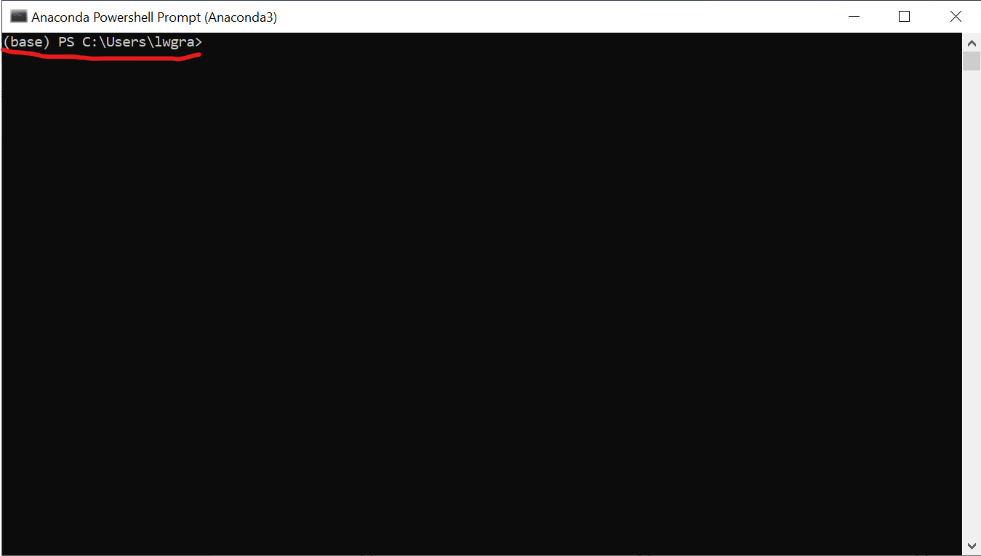
7. Next, You need to change to the directory that contains your jupyter notebooks (this is the absolute or relative path ) and type “jupyter notebook” to launch it into a web browser.
8. 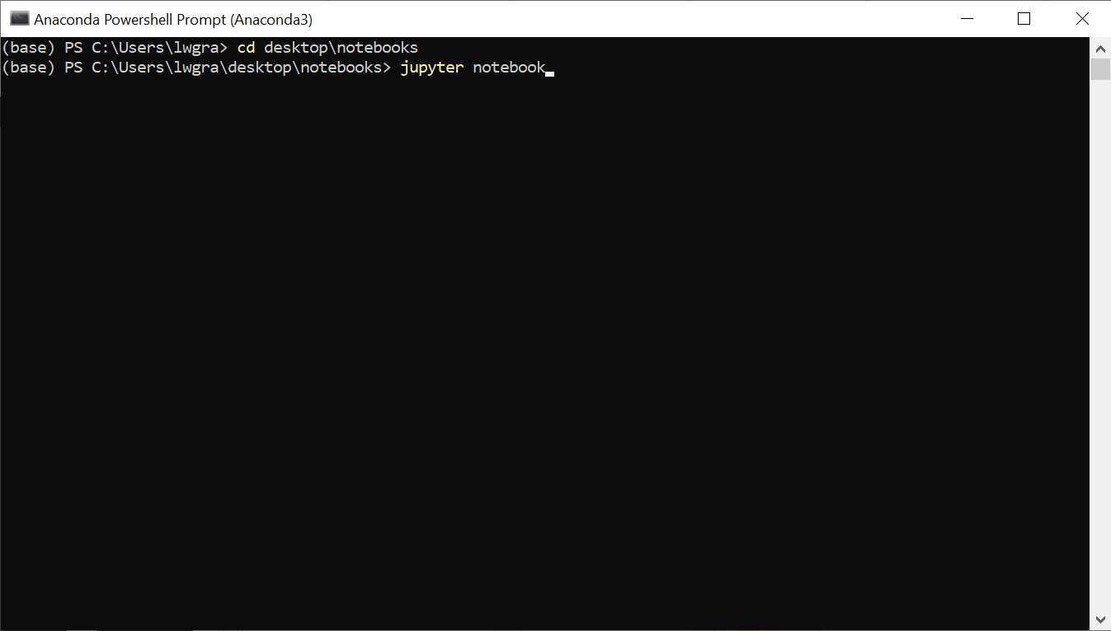
9. This is what your Anaconda Powershell Prompt will look like once you type “jupyter notebook”
10. 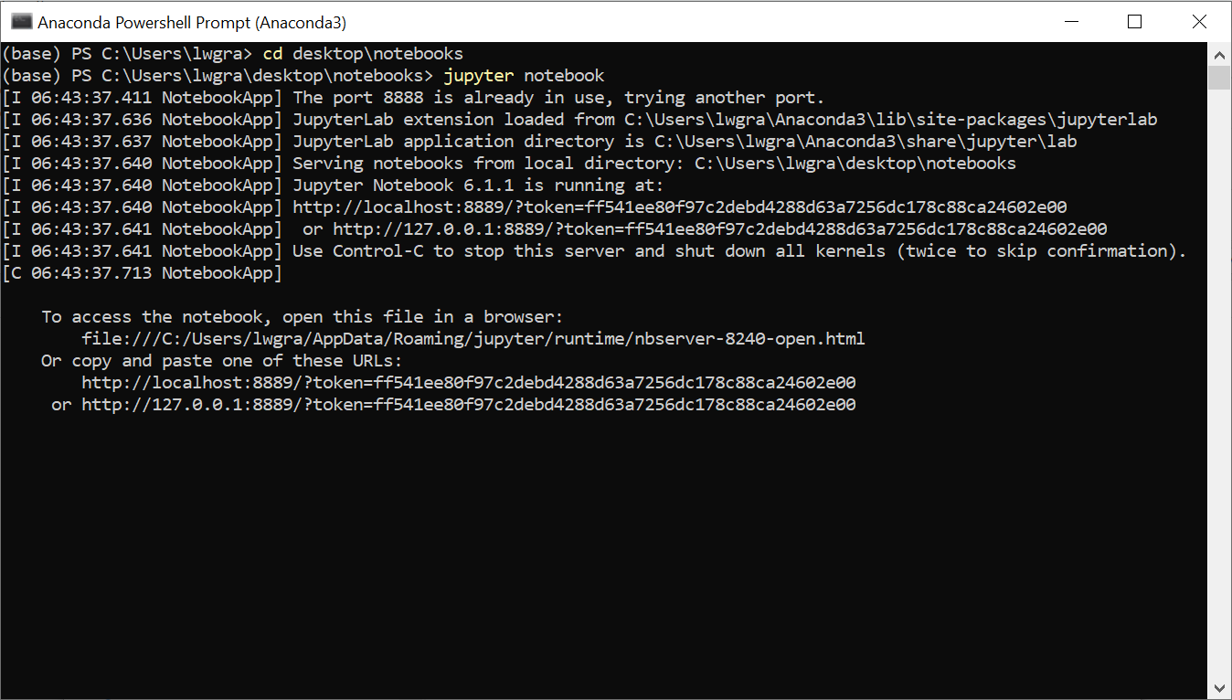
11. Automatically a browser window with jupyter notebook will open
12. 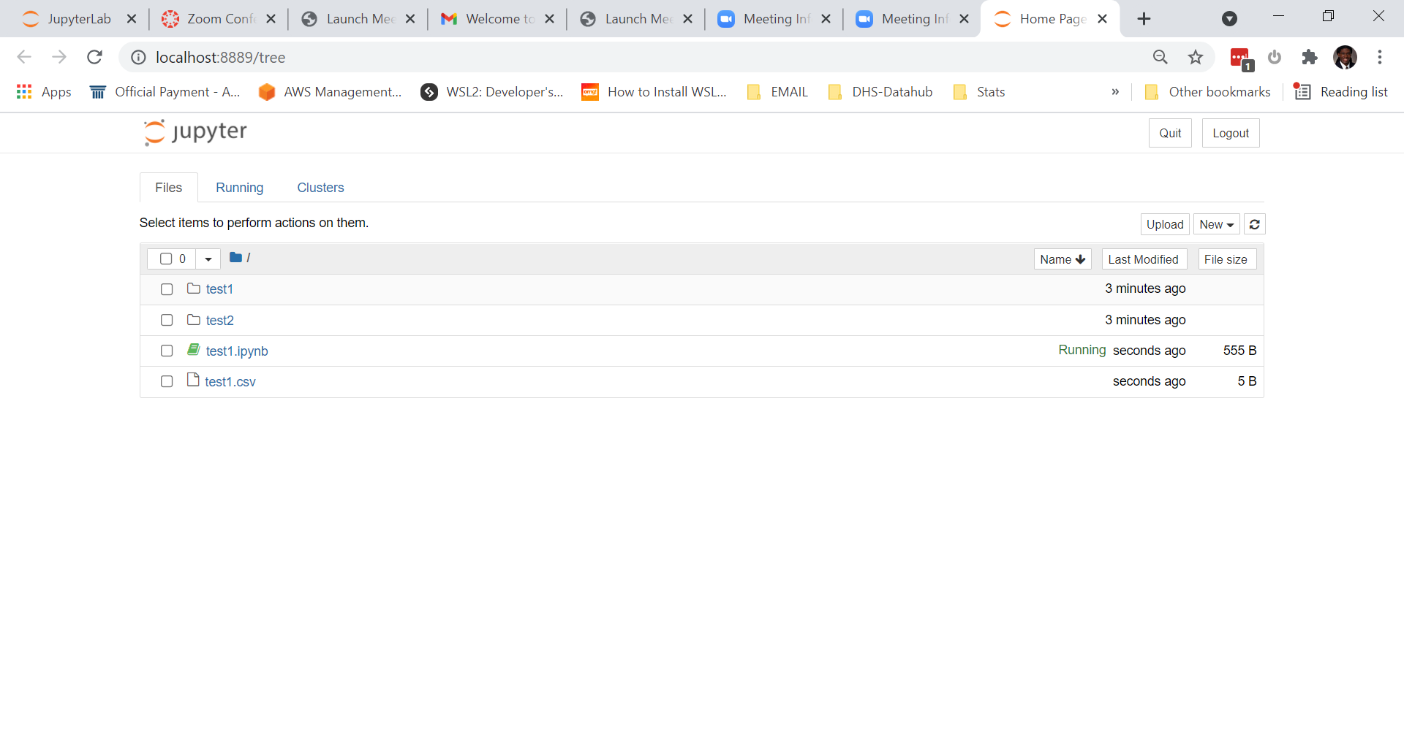
13. You can now click on a notebook file (.ipynb) and begin your work.